Political cartoon
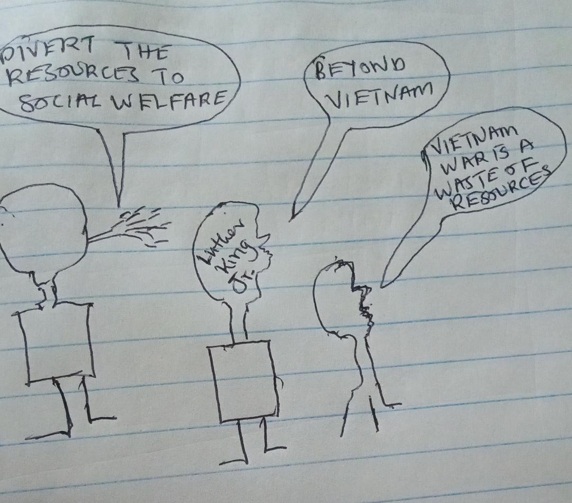

This political cartoon shows some Americans opposing the Vietnam War. These people cited waste of resources as the reason for opposing the bloody war. Led by Martin Luther King Jr. these Americans felt that the Vietnam War was a waste of resources that could be channeled to help the poor. They wanted the government to focus on social welfare instead of engaging in military war. According to Luther King Jr, the money that was going to the war would be used on anti-poverty programs. He was quoted that a country that spends a lot of money in military defense than on social welfare was approaching its spiritual death. In his speech “Beyond Vietnam” Luther King Jr pointed out that Vietnam War diverted money and attention from domestic programs created to help the poor. He also felt that America was after imperialism engaging in the war. Luther King was one of the Americans who felt that the government ought to have concentrated on the domestic affairs and avoid participating the Vietnam War. He was walking his calling of fighting for justice, equality and fighting against oppression of the poor.

